FOR IMMEDIATE RELEASE

MAST Academy, the Maritime and Science Technology magnet school located at 3979 Rickenbacker Causeway, recently held its 12th annual Dade Partners/Mentor Breakfast (Thursday, April 15). The event, catered by MAST's culinary arts department, drew over 50 community and business leaders, as well as school administrators, key faculty and members of the PTSA (Parent Teacher Student Association) to discuss ways in which the groups can work together to enhance specific educational programs at MAST Academy.

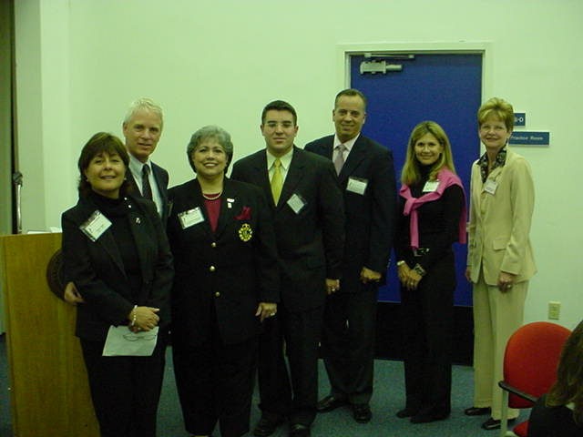

Show in the photo (left to right: Moni Cohen, Event Co-Chair, PTSA; Mayor Robert Oldakowski, Village of Key Biscayne; Dr. Consuelo V. Dominguez, MAST Principal; Francois Ilias, Chief of Staff for Mayor Manny Diaz, City of Miami; Carlos A. Saladrigas, Administrative Asst. to Mr. Agustin J. Barrera (Miami-Dade County Public Schools, District 6); Debra Leibowitz, Event Co-Chair, PTSA; and Cathy Hamilton Green, Supervisor, Dade Partners, Miami-Dade County Public Schools.

For further information, contact Debra Leibowitz, 305/531-7887 or adsetcinc@the-beach.net

